In this lesson we will learn about How to use Modal in React native Som people call it Dialog Box whatever you call it but in react native its official name is Modal and in this lesson we will use modal term and now the teacher is showing what we are going to build it as shown below



0:18

So we will have a button in bottom we add it title as open now as we click on it then a dialog box will be there and again there will be button in the dialog box and its title is close and when we clic on close button then that dialog box will be closed as shown above

If you want that then you can add a close button in the corner of the dialog box with the help of stylesheet you can try it in upcoming lesson teacher will tell how to do it and how you can make a custom modal here The modal component we are going to create here is given by react native but if you want then you can make your own modal by the stylesheet and it is often asked in interviews that how you can make a custom model by css and its answer you can learn by in the upcoming lesson when we will make a custom model For now we will see the default model. First of all we need a button and we will import the modal and we import both and then we will add a style on the button so the button will be placed on the bottom and this modal should be in the center because if you will not apply styles on it then then it will be shown on the whole screen there will be no shadow shown so we will fix it later we will take a state and then with this state and button we will show and hide the modal and then in last we will be asked some interview question

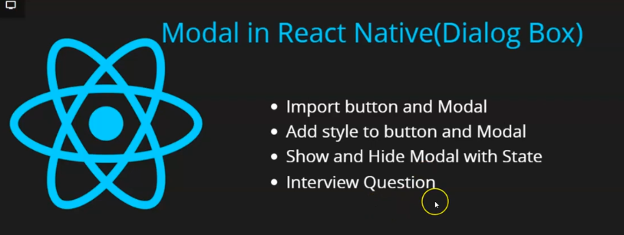

Even interview question are not often made on modal the directly ask you where you use the modal

You can say where we want to show quick information or show warning or error message or if you want to update a field quickly (who knows) then they could use modal there and they could ask you that how to add animation in modal and you might have observed that when we close the modal then it get closed by the slide down and by slideup it is opening. So there is animation of fade or slide so show you can apply it teacher will tell us this and here we will see some food properties of css here so we will see the whole lesson

2:25

So our initial code look like below

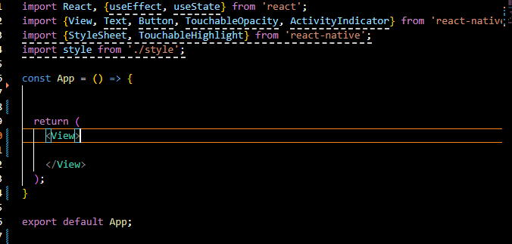

Now you can see above the code and there is no much written here and our screen is black . Now we import button and modal



Now we give it a title now our design code look like below

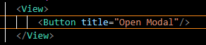

Our output will look like below

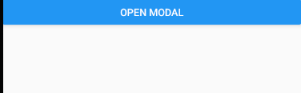

Now you can see it is in top and to make it in bottom you need to apply style on it So we import stylesheet here as shown below



Now we declare a constant for our stylesheet that is styles and we add a property there that of main in it and we add a flex of 1 in it. So now we add it to the top view in our design cide so that th top view will cover the whole screen Now to place button we take view inside our another outer view covering the Button because if we outer most View then where we will keep the modal (who knows)

And second reason is that we cannot apply styles on our button and teacher has told it already in his previous lesson and you can use Touchable opacity for it but color has already a default applied so it saves our time and we have to also place it at the bottom of the screen

We add a buttonView properties in styles variable to the outer view style surrounding the button Now to make the view containing the button stretch we add flex: 1 to it and then give justify-content:flex end (maybe it will make the elements inside that view start from bottom to top)

Now our code look like below

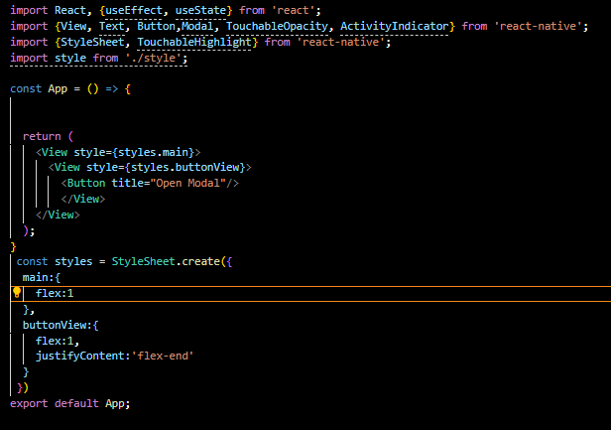

Now our output look like below

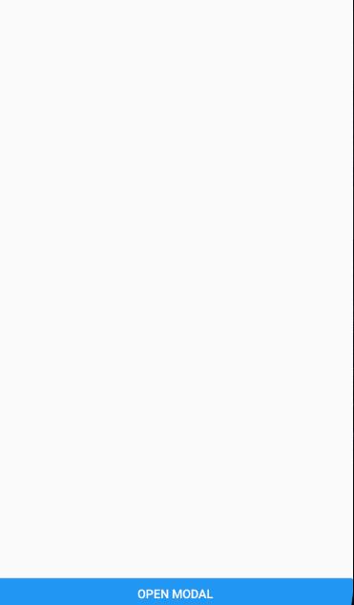

Now this work is completed now we come to our modal

Now as we add modal to our design (you can add it at top or below or anywhere) So we add a modal and we treat it as an container element and there are properties inside it we will see it but we add some more component inside it as it is a container element so we add a view inside the modal and we need to add some style here and we can add one more view inside this view now the first view inside the Modal will be treated as wrapper and the view inside it will be used to control the text so we can add the some Text inside the deepest view in modal

6:00

Now our design code look like below

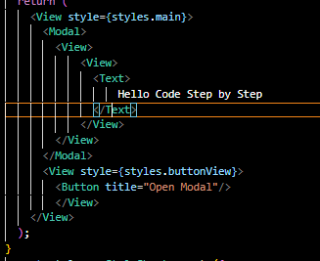

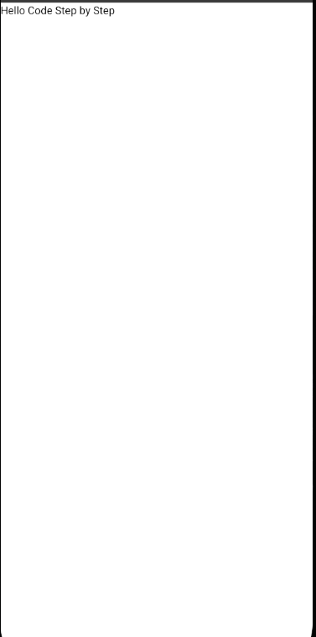

Now you can see the text but it is above the white backgound and the button is hidden

It is because modal by default covers the whole screen and because of this the button got hide so we need to add styles here so that it will not look big to you and its background color is white in color Teacher will show us that what props to use to change it(who knows) Now there is property called transparent and if you add it on the Modal then you can see the background it covers So it will be added like below

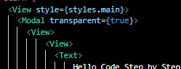

Now you can see the button but you will not be able to click on it as shown below



So we will adjust our modal so first we style our modal How to close it will be told by the Teacher now we add another property to style and we name it centeredView and we add it to 1st view inside Modal and we add again another property to the styles which will be applied to the view that represent text of the modal that is modalView. Or you can wrapper it ( who knows maybe adding another view surrounding the view that represents the text in Modal and then applying styles on it )

8:00

Now we will style one by one first we will style the centeredView. We give it flex:1 so that it has flex and cover the whole area occupied by modal and then add justify content that is of center By this our text will be in center vertically

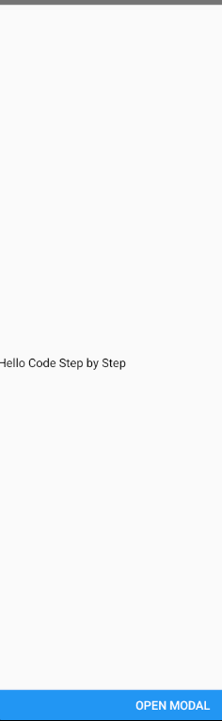

And then we add alignItems to the centeredView and give it value center so that not it is vertically as well as horizontally in center. Now our output will look like below

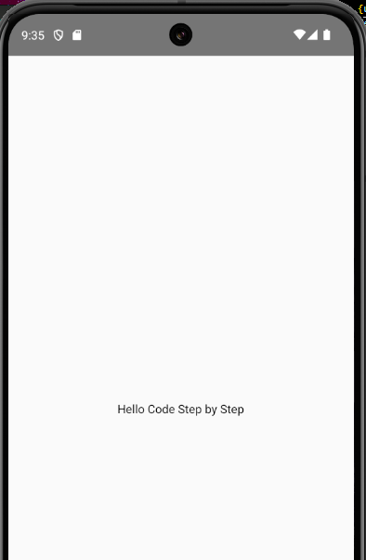

Now our text is in the center. Now give styling to modelView that was representing the text of the modal Now as you know we has mode modal transparent so the white color in the bg you see is of the screen not of modal but we can give background color to modalView we give it skyblue color by later we will kae it white but for now teacher will show how much area the text is covering Now we give it padding of 40 so that it can grow (who knows) Now output look like below

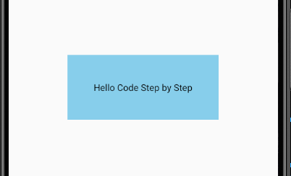

Now we give it border radius of 20 pixel now since text is a part of view representing the text Its corner will be rounded as shown below



Now we give it some shadow of black color and now to apply shadow we use properties like elevation we give it numerical value of 5 now you can see the shadow formed in the output

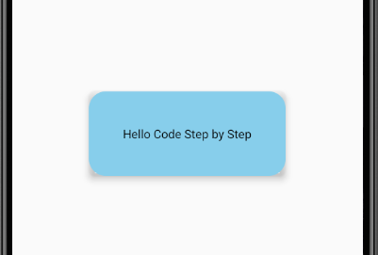

Now we add another property in styles that is modal to the Text component in the Modal we add fontSize of here is 30 and in modalView make the padding 30 and add a button below the text of title Close Modal. It will be brloe the text equal to the size of text because of padding and we will make the background color in modalView white instead of skyblue now our code look like below

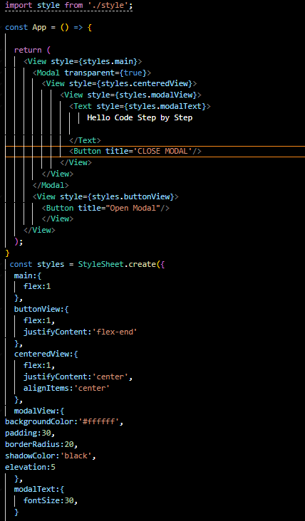

Now our output will look like below

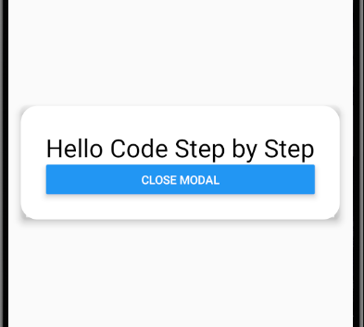

Now to gice soace between the text in modalText property we add marginBottom of 20 pixel now our modelText property look like below

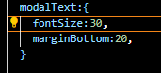

Now our output look like below

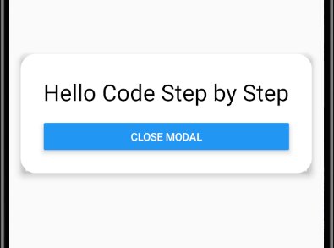

The close Modal can be clicked but open Modal cannot be clicked SO now we need to make it hide and show and otherwise our UI is remaining now we need to hide and show the modal for that simply take a state we name showModal and set its updation method is setShowModal. We will take showModal bydefault as false Now how to make a modal hidden by default, there is a property in Modal that is **visible** it make the modal visible or hidden and we pass it showmodal so it will become hidden by default as shown below

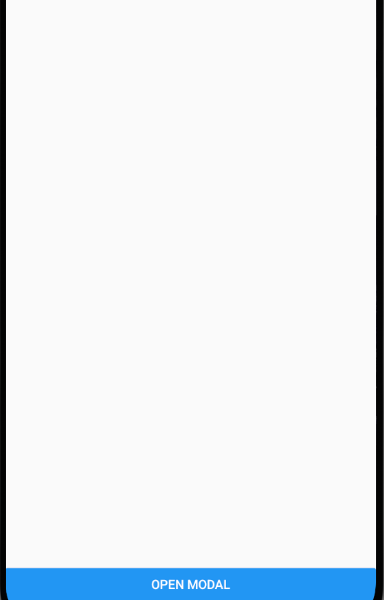

Now we add an onPress on our open Modal titles button and pass it a callback function that set showModal to true such that the Modal become visible

Now our output look like below



Now we need to close it, to close it we add onPress on our CLOSE MODAL titled button and pass it a callback function that set showModal to false such that the Modal become invisible when we click on CLOSE MODAL present on the modal as shown below

Now you can open a modal and close a modal but Teacher was talking about animation so for that there is another props in our Modal that is animationType and if I give a value slide to it then

14:12

It will make the closing and opening of the modal will be done in a slide animation when a modal opens up then it slides up and if modal classes then slides down.

Now suppose we set animationType to slide Now our code look like below in Modal



Now our output look like below



Now in modal code we set the animationType fade as show below



Now our output look like below



Now you can see now the modal is opening and closing by dim (who knows)

By default there are three values for animationType but we set it to slide

You can modify modal all you want you can add textbox in your modal. In upcoming lesson we will know how to make a custom modal instead of using inbuilt Modal of React native so that’s all for this lesson. Our code now looks like below

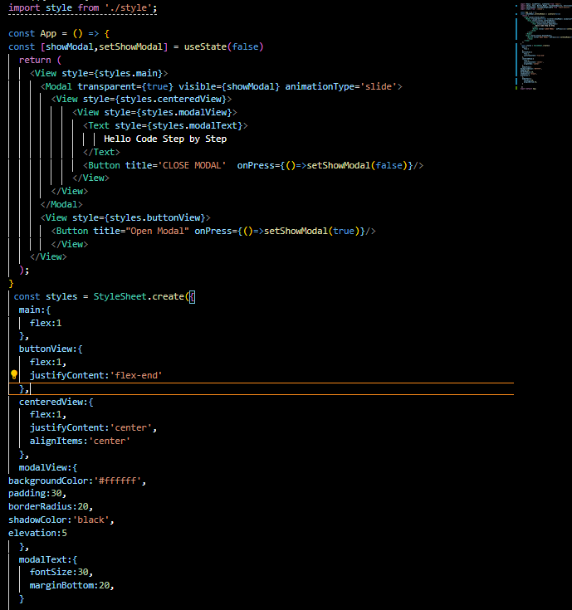

See you in the next lesson.